Ok so
Part 1:
fibonacci.c
We have a logical error we are doing:
> last = next;
>second_last = last;
What we should be doing is
> second_last = last;
>last = next;
How do we we know there is a problem here?
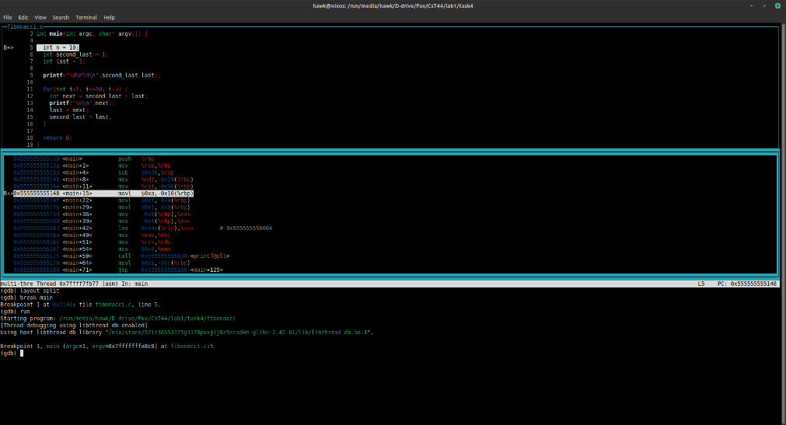
First we start gdb
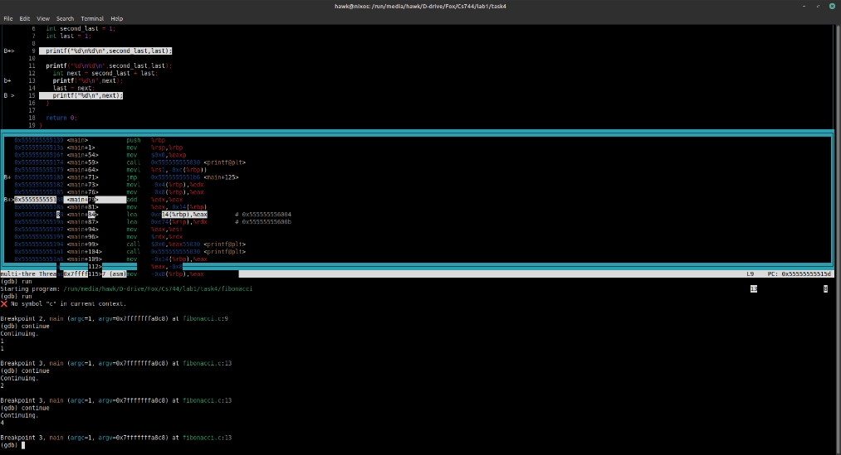
Then we run the code with a few break points and we can see that 4 is wrong. Then we investigate further.

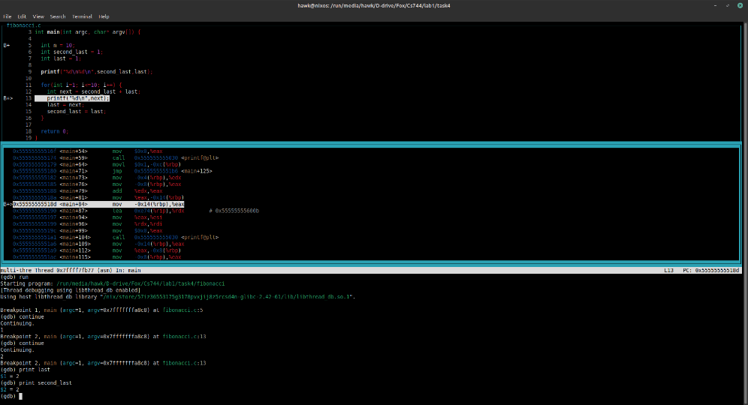
Here we see that the values in last and second last are wrong so we can conclude that the assignment of values has a problem.
Investigating further we can notice the bug.

Part 2:
pointers.c
We have a segmentation fault because of referencing a null pointer. 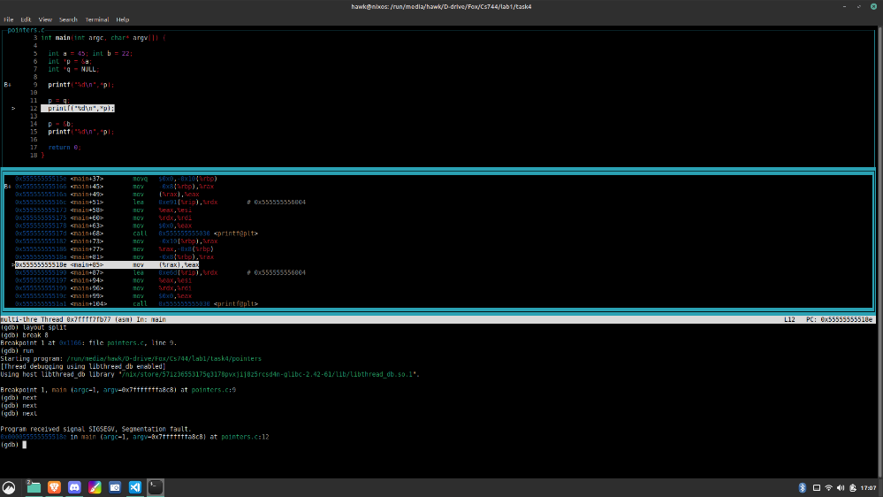
Here we can see the line of the segmentation fault is 12.

